2020 FACT SHEET

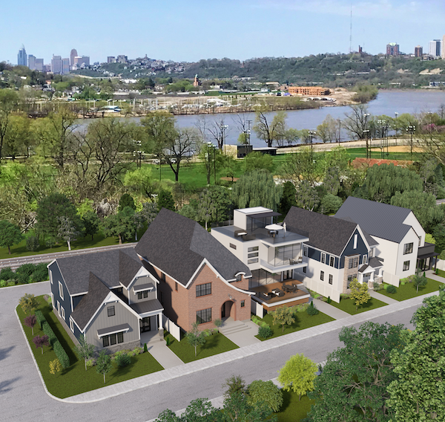
HOMEARAMA® is the registered trade name for the single-site new home showcase produced by the Home Builders Association of Greater Cincinnati. The 2020 show will mark the 57th year for the new home showcase. HOMEARAMA® regularly attracts thousands of enthusiastic Cincinnatians. HOMEARAMA® 2020 will feature eight (8) fully decorated and landscaped homes in a variety of architectural styles and for the first time in the history of the show it will be held in the City of Cincinnati. The homes will range in price from $1.2 M to 1.6 M.

Developed by East End Development, LLC, (Meierjohan Building Group – TJ Ackermann and Ralph Meierjohan), Walworth Junction is an urban “infill” development containing 39 single family lots located in the City of Cincinnati’s Historic East End neighborhood. Walworth Avenue is located just north of the intersection of Riverside Drive and Delta Avenue, immediately adjacent to The Precinct Restaurant. The site was formerly the Pennsylvania Rail Road’s Pendleton Yard and contained a Round House, a Turntable, and multiple other structures related to railroad operations.
Walworth Junction is a “walkable” community with sidewalks connecting it to the business districts of Columbia Tusculum and East End’s Riverside Drive. Riverside Drive connects directly to downtown Cincinnati and has dedicated lanes for bicycle enthusiasts. There is a public pedestrian tunnel at the eastern edge of the property which provides connection from Walworth Avenue to Riverside Drive, directly across from the High Mark Bar, Emma’s Wine Bar, and just down the street from Eli’s Barbeque.
Walworth Junction is located within the Cincinnati Public School District. Additional school options close by include St. Ursula Villa, The Summit Country Day School and St. Ursula Academy.
Show Dates/Hours
Dates - Saturday, October 10th - Sunday, October 25th
Hours - Monday – Thursday 4:00 PM – 9:00 PM; Friday – Sunday 12:00 Noon – 9:00 PM

Ticket Prices
Tickets are $19.00 at the gate; and, $17.00 on the Cincinnati HOMEARAMA® app or online at cincyhomearama.com. Kroger will NOT be selling event tickets in 2020 due to COVID-19 restrictions. A special TWO-DAY ticket will be available for $29.00 at the gate only. New this year . . . purchase your ticket online at cincyhomearama.com or on the Cincinnati HOMEARAMA® app for $16.00 and attend Monday – Thursday to help us spread out the show attendance. This special ticket price is ONLY available online or on the Cincinnati HOMEARAMA® app, NOT AT THE GATE. AND, YOU HAVE TO ATTEND MONDAY – THURSDAY FOR THE $16.00 PRICE. It is very possible that there will be lines at this year’s show, especially on weekends, due to social distancing and the number of attendees that will be allowed in each house at one time. Children 12 and under are admitted for free if accompanied by an adult. No tickets sold or admittance to the show after 8:00 PM.

- 1 -
Directions
From I-71, Take the Red Bank Road exit, Turn left on Brotherton Ct., Turn slight Right on Erie Avenue, Turn left on Delta Avenue, Turn left on Linwood Avenue, Turn slight right on Delta Avenue, Turn right on Walworth Avenue.

From I-75, Take the Norwood Lateral/OH-562 toward Norwood, Merge on I-71 South toward Cincinnati, Take OH-561 South to Edwards Road, Turn left on Williams Avenue, Turn right on Edwards Road, Turn left on Observatory Avenue, Turn right on Linwood Avenue, Turn slight right on Delta Avenue, Turn right on Walworth Avenue.

From Columbia Parkway/US-50, Take Columbia Parkway to Stanley Avenue, Take 2nd right on Eastern Avenue, Eastern Avenue becomes Walworth Avenue.

GPS Address - 3107 Walworth Avenue, Cincinnati, OH 45226.
Please note, this is the show address and there is NO ON-SITE PARKING AVAILABLE. SEE PARKING OPTIONS BELOW. You can use this address for handicap parking or handicap drop off. You must have a handicap parking sticker or pass to park in the handicap parking lot, no exceptions.

Parking for the show
Schmdit Boat Ramp and Sports Complex (2944 Humbert Avenue, Cincinnati, OH 45226), 360 paved parking spaces will be available for HOMEARAMA® show attendees. Once you park at Schmidt Boat Ramp and Sports Complex you will walk approximately ¼ mile, cross Riverside Drive with a crossing guard and take the tunnel and steps up to the show site on Walworth Avenue.

Lunken Playfield (4740 Playfield Lane, Cincinnati, OH 45226), 153 paved parking spaces will be available for HOMEARAMA® show attendees. Once you park at Lunken Playfield you will take a bus from Lunken Playfield to a drop off location at the show site. Buses will run continuous from Lunken Playfield, to the show site and back to Lunken Playfield.

Peddlers Flea Market (4343 Kellogg Avenue, Cincinnati, OH 45226), 500 paved parking spaces will be available for HOMEARAMA® show attendees. PLEASE NOTE - on Saturdays and Sundays the Peddlers Flea Market parking lots are not available until 2:00 PM due to the flea market. THERE WILL NOT BE ANY BUSES AVAILABLE AT THESE LOTS UNTIL 2:00 PM on Saturday and Sunday. You will take a bus from Peddlers Flea Market to a drop off location at the show site. Buses will run continuous from Peddlers Flea Market to the show site and back to Peddlers Flea Market.

Important Show Information
There is no charge for parking. THERE IS NO ON-SITE PARKING. The HBA, HOMEARAMA® or the owners of the parking lots are not responsible for valuables that are left in cars. There will be parking attendants at each parking lot.

Local food trucks will be on site each day offering a variety of food and drinks for show attendees. Restrooms are available on site. Numerous events are being planned for HOMEARAMA® 2020. All events will be listed on the HOMEARAMA® website cincyhomearama.com.

No strollers, wagons or child backpacks with metal frames are permitted in the show homes. No pets are permitted within the show site, except for service animals. You must have documentation to verify that the animal is a service animal. We suggest that you wear gym shoes or flat shoes to HOMEARAMA®. There is a considerable amount of walking at the show and there are steps in most of the homes.

We are taking extra precautions due to COVID-19 including sanitizing all public areas, restrooms and the concession area hourly. There will be lots of reminders about social distancing (6’). There will be hand sanitizing stations throughout the show and guests are encouraged to bring your own mask and wear it while visiting the show. We ask that you please be patient with us as we follow the State of Ohio COVID-19 guidelines to ensure your safety as well as the safety of our show staff, the show builders and their personnel.

- 2 -
HomeZone Exhibit Tent(s)
Check out the newest home products in the HomeZone Exhibit Tent(s) within the show site which will include over 15 vendors.

HOMEARAMA® is produced by the Home Builders Association of Greater Cincinnati
11260 Chester Road, Suite 800, Cincinnati, OH 45246
Phone (513) 851-6300 • Fax (513) 589-3211 • cincybuilders.com
For HOMEARAMA® information visit cincyhomearama.com
in conjunction with
City of Cincinnati
801 Plum Street, Cincinnati, OH 45202
cincinnati-oh.gov

- 3 -

